< Tian Xie >

< 3/9/2020 >

< IT FDN 100 >

< Assignment 07 >

Document my knowledge

# Introduction

For the 7th assignment, the task is to modify last week’s assignment to handle structured errors that we anticipate.

This week I attempted to learn about exceptions, binary file, and class.

# Steps to Complete the Assignment

To complete the assignment, I watched the recommended YouTube videos and read the book. Then I followed all the steps in the assignment document.

The first thing I did was to identify the places where an error could occur.

The first one I thought of is the file not found error. When the program reads the file, if there’s no file in the directory, the program will stop and get an error. I researched this and found that there is a Python default error called “FileNotFoundError”. So I used try..except method to create a warning to the user that there’s no file in the directory.

Second, I wanted to take a look at all the required user input and tried to think about what could go wrong. So I added ValueError for user input functions to ensure that the ID entered is a number.

Then I started working on the pickling part of the assignment, first I imported pickle.

Then in the write_file and read_file function, I used wb and rb to indicate a binary file, not a text file.

Then I used pickle dump and pickle load functions to load and write binary data.

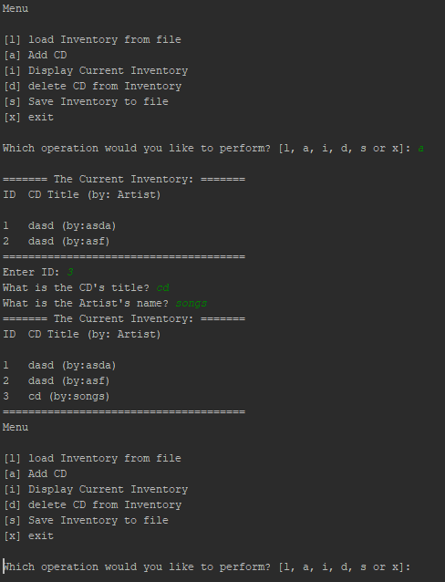

Figure 1Pycharm Screenshot showing adding works

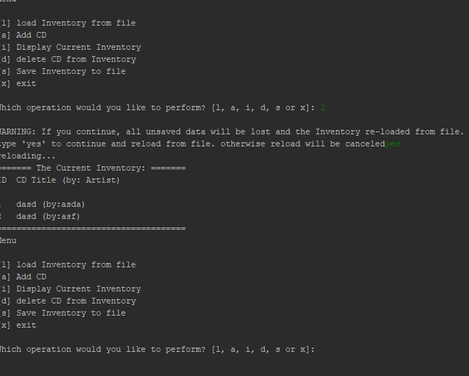

Figure 2S Pycharm screenshot showing loading function works

# Summary

Module 07 was definitely more challenging. Learning pickling and unpickling to write and read files proven to be very useful. Learning try except really opened up a ton of opportunity to explore and really dive into UI development.

# References

<https://docs.python.org/3/tutorial/errors.html> for step 3 research exception handling in Python

<https://www.programiz.com/python-programming/exception-handling> for step 3 research exception handling in Python

<https://docs.python.org/3/library/pickle.html> for step 4 research pickle in Python

<https://www.geeksforgeeks.org/understanding-python-pickling-example/> for step 4 research pickle in Python

The pages I found were pretty good at explaining of exception handling because it’s straightforward and easy to understand. The pages come with examples and screenshots.

# Appendix

Github link: https://github.com/tianxie812/Assignment_07